Weekly Sprints – AR Serious Game

Contents

Weekly 2

Week 2 Sprint 2

Week 3 Sprint 3

Week 4 3

Week 5 4

Week 6 6

Week 7 6

Week 9 7

# Weekly

|  |  |  |  |  |  |  |  |  |  |
| --- | --- | --- | --- | --- | --- | --- | --- | --- | --- |
| Jan 18th | Jan 25th | Feb 1st | Feb 8th | Feb 15th | Feb 22nd | March 1st | March 8th | March 15th | March 22nd |
| 1 | 2 | 3 | 4 | 5 | 6 | 7 | 8 | 9 | 10 |
| 0 | / | / | / | / | / | / | / | / | / |

|  |  |  |  |  |  |  |  |  |  |
| --- | --- | --- | --- | --- | --- | --- | --- | --- | --- |
| March 29th | April 5th | April 12th | April 19th | April 26th | May 3rd |  |  |  |  |
| 1 | 2 | 3 | 4 | 5 | 6 |  |  |  |  |
|  |  |  |  |  |  |  |  |  |  |

# Week 2

## Discussion

Talked about different ideas and how they might be implemented.

* AR game with animals and fighting with QR codes.
* AR game with bugs that can tell the user about the different style of bugs.

Discussed different ways that Crowd Simulation could be used.

* AR game simulating crowd in a disaster and how to react the best to it.
* How AR can be utilised inside the tourist app idea
  + Number of points would equal the number of characters is in the game. When the player defeats a level and gets X points, the home village would get X new villagers.
  + Characters can be interacted with

Discussed the art style and assets.

* Liked the style of Luka’s Big Ben.
* Discussed the style of the characters and how they would work in the environment.
* Discussed future assets.

## Deliverables

|  |  |
| --- | --- |
| **Person** | **Deliverables** |
| Dan | * Basic AR functionality * Villages and Exploration prototype |
| Luka | * Character Prototype * House Prototype |
| Gino | * Playfab Login |
| Neshko | * Quiz UI Systems * UI Mockups |
| Jai | * Crowd Simulation Prototype * Testing |

# Week 3

## Progress

Gino: save stats and game login with playfab. Saved data such as player level, and coins.

Dan: village, and scene transition prototype in AR.

Neshko: world UI prototype.

Jai: Limit testing with the crowd simulation. Worked on creating a waypoint system, but also worked on Navmesh prototype.

Luka: Eiffel Tower and House, characters. Updated Big Ben and some foliage

## Discussion

Europe: France (Eiffel Tower, Louvre, Arc Di Triomph): England (Big Ben, London Eye, Stone): Italy (Colosseum, Pisa Tower, Duomo): Bulgaria (Sunny Beach, Saint Aleksander Cathedral, Rile Monstery)

Asia: China (Great Wall of China, Forbidden City, Something Else).

## Next Week

Neshko, UI Interface for the Main Menu scene, as well as quiz interface.

Dan, expanding the prototype to add the level variables.

Gino, Finish the database stats. Look at Asset Bundles for database.

Jai, work on stable crowd and interactions with model.

Luka, finish character variations, England sculptures.

# Week 4

## Progress

**Gino:**  Worked on the Leader board functionality for the game.

**Luka:** Worked on different character variations as well as England models London Eye and the Gherkin.

**Neshko:** Worked on planning some UI flow in illustrator.

**Dan:** Worked on the AR flow of the application and how the user will interact with the AR

**Jai:**  Worked on AR crowd simulation prototyping

## Discussion

Procedurally generation of character to add more variety within the characters.

* How might the procedural generation work alongside the different types of characters.

The base bowl and look of the game. How the base of the thing might work and the effect of that on the user. Could the base board have a big effect on the gameplay or be “iconic”

* Dog bowl,
* Snow globe
* Water shader

UI and target audience

## Next Week

**Gino:** AssetBundle from Playfab.

**Luka:** Roads and the Contingent

**Neshko:** Art styles and quiz.

**Dan:** Trying to integrate some of Neshko’s UI aswell as Luka’s models with some animation. Working on the core gameplay systems. Water shader.

**Jai:** Crowd Simulation and optimisation.

# Week 5

## Progress

**Gino:**  Started working on Azure

**Luka:** Road tiles

**Neshko:** UI in Illustrator

**Dan:** Fixes to the UI flow.

**Jai:**  Fixed the crowd simulation!!!!!

## Discussion

Discussed application flow of the game, getting most of the game inside one scene in order to get the game mostly playable.

Discussed the different art variables and how we are going to implement them.

* Scrap the idea of having different islands.
* Instead make bigger cities with the different parts inside them

Discussed Neshko’s UI

Discussed Jai’s crowd Simulation and the fix to the different bugs.

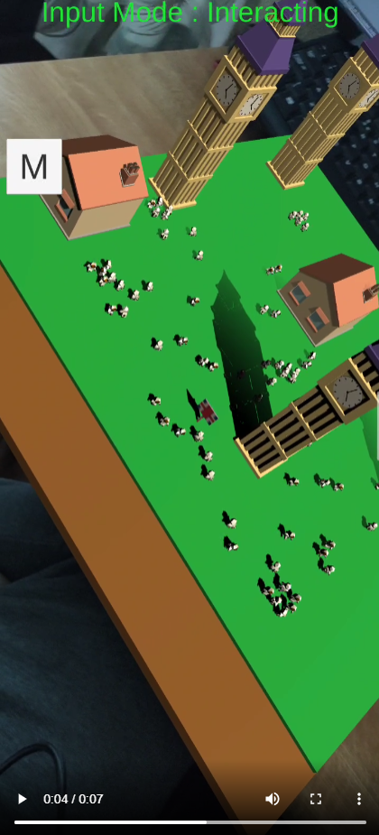

## Next Week

**Gino:** Microsoft Azure implementation, downloading Blob files from Azure.

**Luka:** Buildings, finish UK and start on Italy.

**Neshko:** Responsiveness of the UI, as well as sounds

**Dan:** Main Menu flow with continent. Set up with Luka’s models.

**Jai:**  Improve the AI, instantiation of the UI.

# Week 6

## Progress

**Gino:** Loading panel, with login and register. Working leader boards. Asset Bundle loading on Microsoft Azure.

**Neskho:** Scaling of the UI text as well as replacing the Text. 3D World.

**Dan:** Changes to the flow. Added the new animations for the board. Prepped the locations for the cloud implementation.

**Jai:** Characters move around the pathed locations.

**Luka:** The board and the animation of the board, with the flag.

## Discussion

Discussing download. How to show the user if their download is working or if it’s not. Throttling the download if it takes too long, or maybe rotating the loading icon as fast as the download is.

Discussion on the board. Implementing the different flags and stuff.

Potential fixes for the scaling issues for the board pieces.

Potential fixes for the Android Studio log cat

## Next Week

**Gino:** Cloud Asset downloading

**Neskho:**

**Dan:** Grid system for the road tiles

**Jai:** Advanced crowd simulation AI

**Luka:** New buildings, Street lights to the road tiles.

# Week 7

Neshko not turned.

## Progress

**Gino:** Azure container asset bundle

**Neskho:**

**Dan:** England village prototype, new animations.

**Jai:** Characters move around the pathed locations. Bug fixing for AR implementation.

**Luka:** The lights on the roads.

## Discussion

Next week to sort out the NavMesh when the prefab is instantiated into the scene from the cloud.

Google slides, 2 slides each just on the progress that you have individually made. Include pictures and a video if you can showcase a video.

## Next Week

**Gino:** Cloud Asset download integration. Work with Dan to integrate.

**Neskho:**

**Dan:** Get the roads to get a new animation. Basic light estimation.

**Jai:** Interaction prototype for crowd simulation.

**Luka:** Small animations on characters (walk run idle), the flag.

# Week 9

Neshko not here, but he has a document to go through.

## Next Week

**Gino:** Statistics Implementation

**Neskho:** Documentation from Gino

**Dan:** Implement the flags, Implement Luca’s Globe Animation, Implement new Streets with lights and street animation. Add Shard.

**Jai:** Implement Crowd Sim with England prefab.

**Luka:** Landmarks and maybe characters.

# Week 10

Neshko not here, but he has a document to go through.

## Next Week

**Gino:** Missing panels, menu, score system.

**Neskho:** Implementation of work. Turn easy medium and hard modes into 3 different objects. Changing sprites for picking country.

**Dan:** Sound manager. Score system implementation. Italy and France.

**Jai:** Try and implement it into the England prefab.

**Luka:** Landmarks, volcano with ruins.